**CTF Challenge: Introduction to DevSecOps**

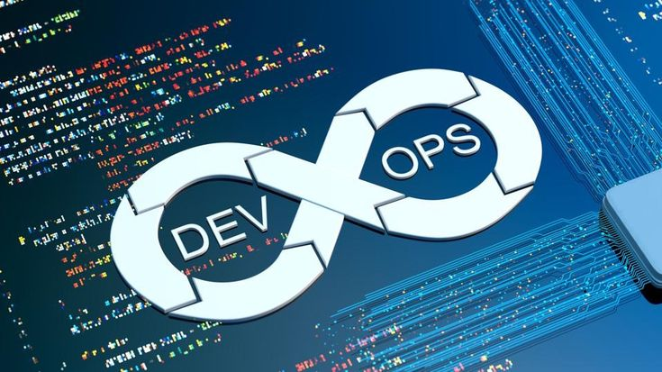

**Introduction to DevSecOps: Bridging the Gap for Secure Software Development**

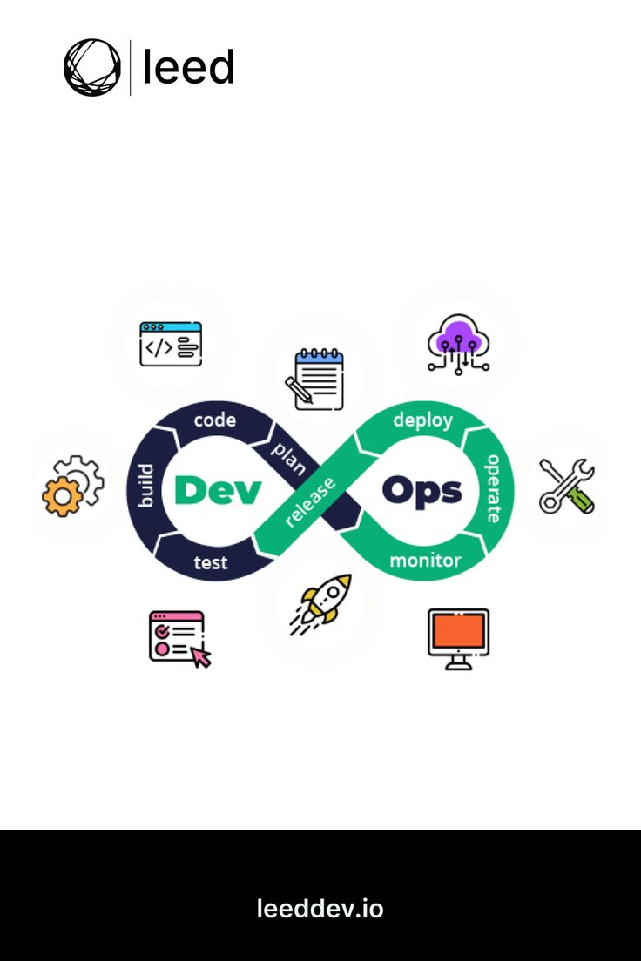

DevSecOps (Development, Security, and Operations) is a security-focused approach to software development that aims to integrate security practices throughout the entire development lifecycle. It fosters collaboration and breaks down silos between development (Dev), security (Sec), and operations (Ops) teams to deliver secure software faster and more efficiently.

**DevSecOps Approach:**

* **Shift Left Security:** Integrate security practices early in the development lifecycle, from design and coding to testing and deployment.
* **Automation:** Automate security testing and vulnerability scanning to provide continuous feedback and reduce manual effort.
* **Shared responsibility:** Foster a culture of shared responsibility for security across all teams involved in software development.

**DevSecOps Tools:**

* Numerous tools are available to support DevSecOps practices, including:
  + Code scanners for vulnerability detection
  + Configuration management tools
  + Security information and event management (SIEM) systems
  + Containerization technologies like Docker and Kubernetes

**Capture the Flag (CTF) Challenges**

**Flag 1. In DevSecOps, what is the philosophy of integrating security practices throughout the development process, not waiting until the end?**

Answer: ShiftLeft

**Flag 2. Which responsibility DevSecOps emphasizes a culture for security across development teams.**

Answer: Shared

**Flag 3. What type of tools can be used in DevSecOps to automate security testing and identify vulnerabilities early in the development lifecycle?**

Answer: Scanners

**Flag 4. What is the practice of automating tasks like testing and deployment within DevSecOps to streamline security feedback?**

Answer: Automation

**Flag 5. How does DevSecOps aim to deliver secure software by integrating security practices throughout development?**

Answer: Faster